**ABC CALL VOLUME TREND ANALYSIS**

**PROJECT DESCRIPTION:** This project is based on call volume report analysis of a call center. ABC is a call center which has a separate team for voice process. In this project we are provided with dataset having details of agents, call duration, time duration, details on calls answered, abandoned and transferred. Data set also contains customer phone number, queue time, IVR time, date and time of call.

Here we have to analyse the rate of call which went unanswered and how many more agents are required to answer the call in both day and night shifts.

**APPROACH:** In this dataset, I first went through the data set to understand the details of the different variables and columns. I checked for any null values, missing or blank cells, duplicate data or if any data cleaning is required. After checking all these fields, I went up to perform the data analysis and answer the required questions.

**TOOLS USED:** MS Excel 2019 and MS Word 2019

**Q1.) Calculate the average call time duration for all incoming calls received by agents (in each Time_Bucket).**

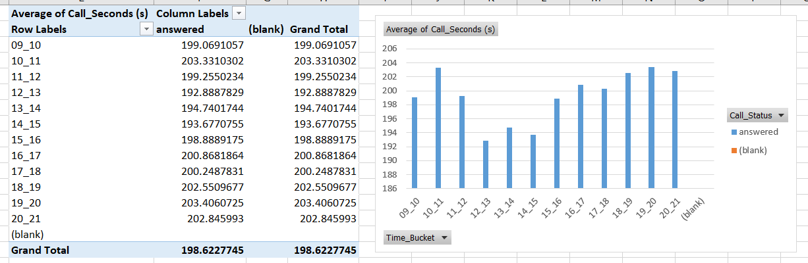

* Average of call time duration answered by agents is 198.62 seconds.
* Average of call duration is highest between 10 to 11 am and 7 to 8 pm.

**Q2.) Show the total volume/ number of calls coming in via charts/ graphs [Number of calls v/s Time]. You can select time in a bucket form (i.e. 1-2, 2-3, …..)**

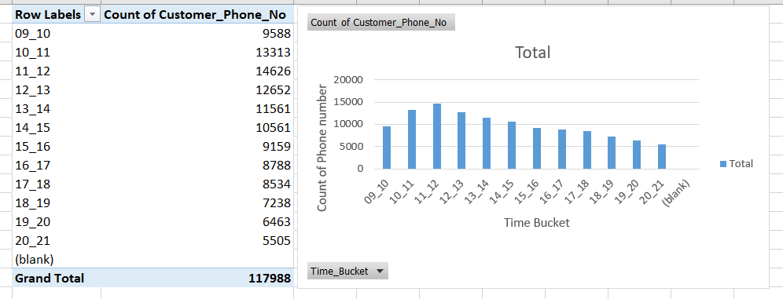

* The number of calls increases from 9 am to 12 noon and then decreases.

**Q3.) As you can see current abandon rate is approximately 30%. Propose a manpower plan required during each time bucket [between 9am to 9pm] to reduce the abandon rate to 10%. (i.e. You have to calculate minimum number of agents required in each time bucket so that at least 90 calls should be answered out of 100.)**

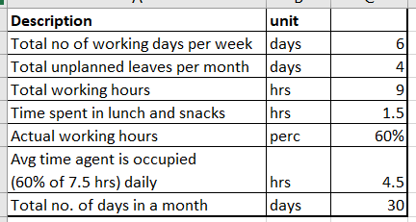

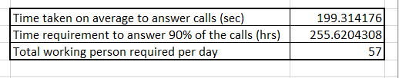

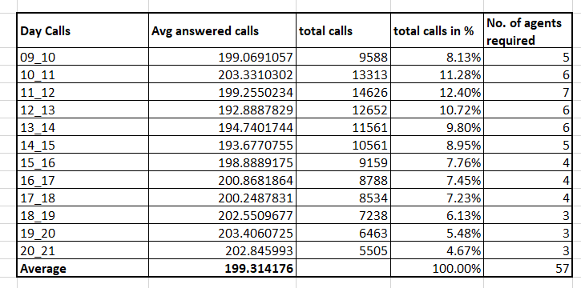

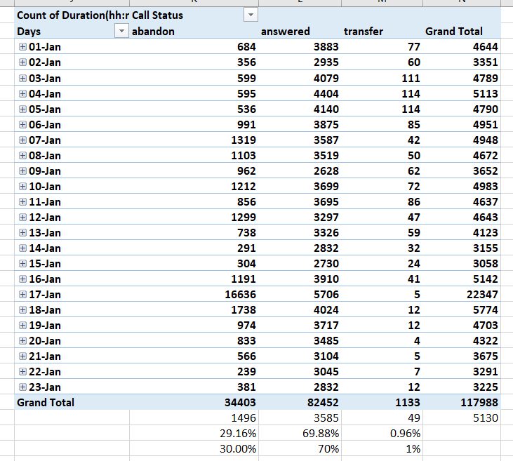

* Total agents required to answer 90% of calls per day is 57.
* The amount of answered calls are 70%, abandon are 30% and transferred are 1% approximately.

**Q4.) Let’s say customers also call this ABC insurance company in night but didn’t get answer as there are no agents to answer, this creates a bad customer experience for this Insurance company. Suppose every 100 calls that customer made during 9 Am to 9 Pm, customer also made 30 calls in night between interval [9 Pm to 9 Am] and distribution of those 30 calls are as follows:**   
  
  
  
Now propose a manpower plan required during each time bucket in a day. Maximum Abandon rate assumption would be same 10%.

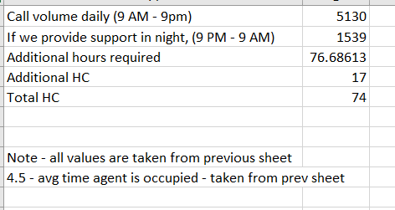

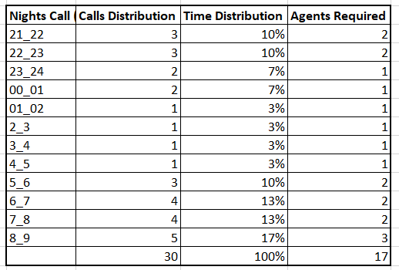

* First calculated the Time Distribution by dividing each calls distribution by total calls i.e. 30.
* Total agents required to answer 90% of calls at night is 17.

Note – The above data only shows the screenshots from excel file. The actual excel file containing all formulas and calculations is uploaded below –



Google drive link for file - <https://docs.google.com/spreadsheets/d/19_rwvYsuj5J1OXcUoR0wPzERKZ02NFF5/edit?usp=share_link&ouid=112715989555881480949&rtpof=true&sd=true>

Also I found that while opening this file in google sheets, some formatting were changed so it I request to please download and open in MS Excel.

**THANK YOU**